**The Creative Brief**

**Pulp Fiction Webs Comic Creative Brief**

**Project Summary**

Pulp fiction is one of the best crime films. I will be using a scene from the film which I will turn into a comic. The comic will be presented within a website.

**Target Audience**

The site will be directed to a wide range of audience but it will be 18+ as there is a lot of graphic scenes. It will be specifically targeted to pulp fiction fans and anyone who is interested in crime/drama films.

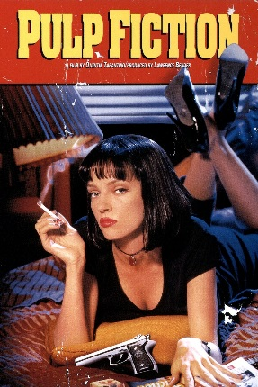**Tone/ Look and feel**

The tone of the of the film is very dark and gritty so the comic and the website will be dark. I will also use the colour red in the website for the header which represents blood. I will also add the colour grey to show the grimness of the film.

The film has very tense moments so in my comic I will try to represent that by being suspenseful.

**Colour scheme and fonts**

The tone of the comic and the website will be similar to the film. As it is a crime movie with a lot of violence the main colours will be black and red. I will also use the colour grey. The font which will be used will be Arial and this will be used for all text. The font size for the main content will be 16, the font size for the header will be 30 and the font size for the navigation bar will be 14 but in bold.

**Target site**

This is a navigation bar from [www.belgrade.co.uk](http://www.belgrade.co.uk) , I like the format and the colour scheme of this navigation bar as it incorporates the colours that I would like to use which is red and black so for my website I will use this type of a navigation bar where the background will be black and the text will be red .

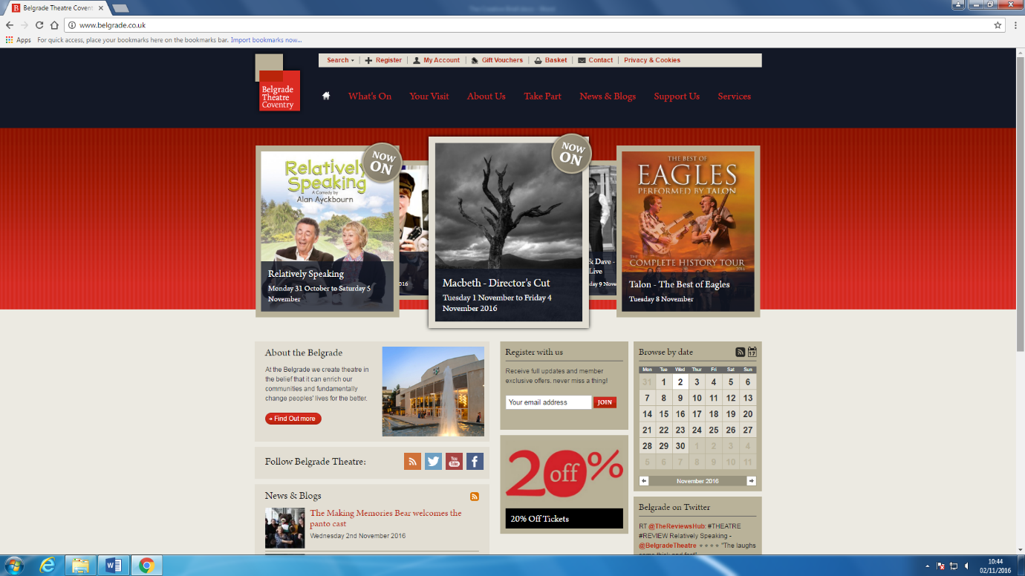

**Layout**

The lay out of the website will be inspired from <http://www.thelittletheatre.net/>

The main content will be in the middle and the sides will be blank as shown below. So for all of the pages the content will be in the middle whilst the sides will have nothing

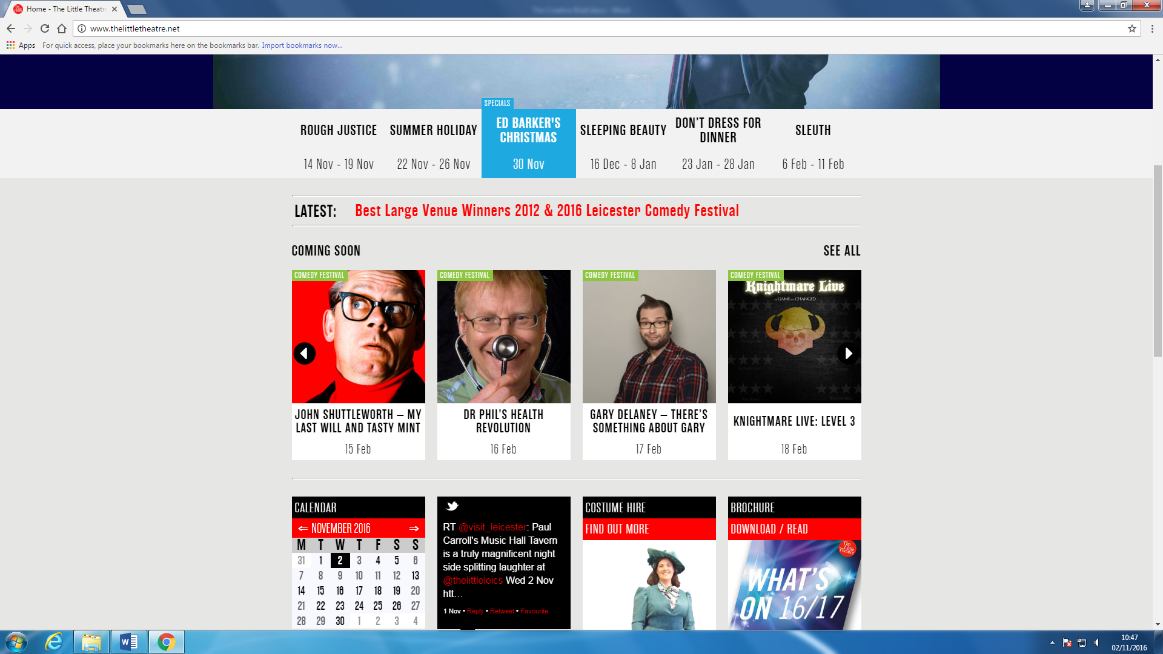

**Graphics and fonts**

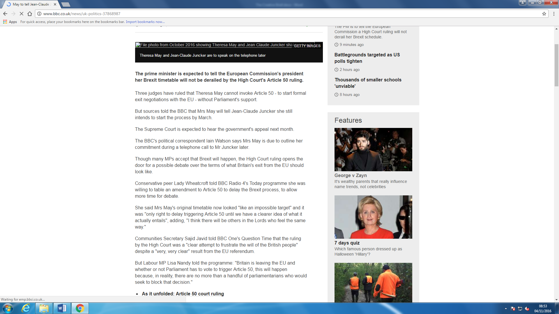I really like the font that used by <http://www.bbc.co.uk/news/> which is Arial so I will be using Arial throughout the website in order to give a professional look so that it is appealing to the users. Furthermore, the font is very clear so users will be able see what I am conveying on the website.

This is a graphic video which is in YouTube format. This is a clip from [www.belgrade.co.uk](http://www.belgrade.co.uk) ,this gave me the idea of putting a video clip in my website.

I will be putting the trailer of pulp fiction on the home page so that the audience is able to see what the film is about so that they can understand what the comic is about.

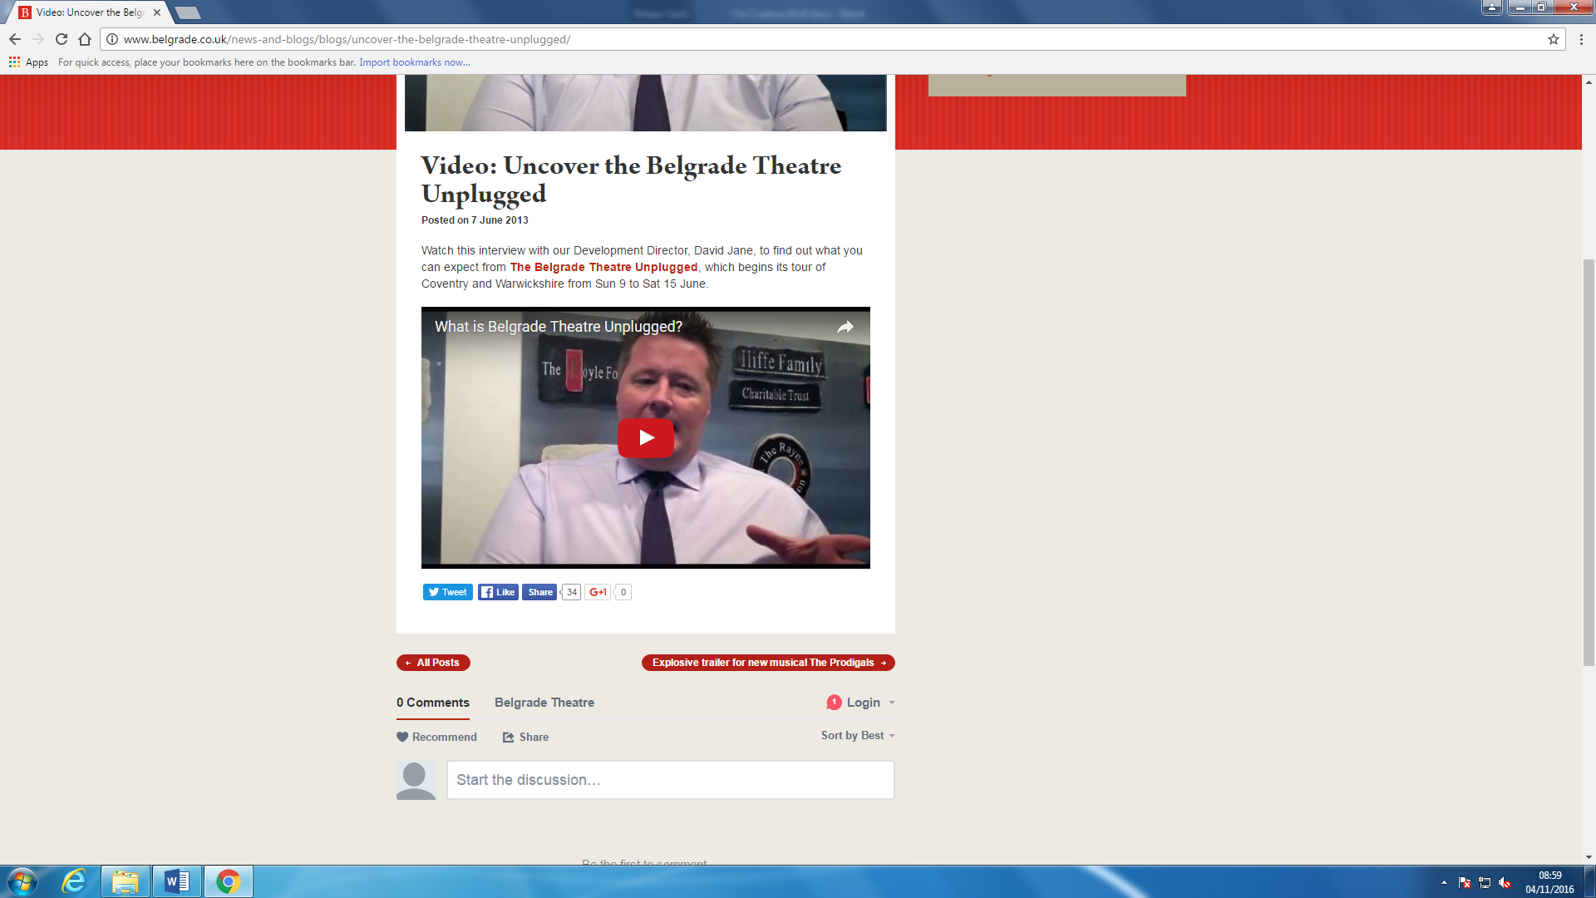

**Navigation Models**

For the navigation model I decided to go with the full web navigation model. The reason I have decided to have a full web navigation model it makes it easier for the user to go on any web page quickly so that the user can have freedom of doing what they want instead of restricting them and making them follow a certain pattern.